

Department of Information Technology
Applications Development Theory 4 (APT470S): Term 3 Research Project
AI-Driven Model Engineering: A Systematic Literature Review of Intelligent Model Generation, Transformation, Validation, and Software Synthesis
Group member | Student number | Research ownership
Thandolwethu Siloyi | 216112303 | Publication trends, database coverage, introduction (RQ1–RQ2)
Phindile Ngozi | 230640893 | AI technologies and multi-agent frameworks (RQ2, RQ6)
Thabiso Matsaba | 220296006 | Lifecycle coverage and transformations (RQ3, RQ5, RQ10)
Zenande Kalipa | 230012035 | Formalisms, metamodels and conceptual framework (RQ4, RQ6, RQ15)
Siyanda Hlati | 219211612 | Validation mechanisms and reference architecture (RQ9, RQ10)
Sibongiseni Tsitsa | 210041919 | Quality assessment, empirical gains and risks (RQ8, RQ11, RQ12)
Phindile Mposwa | 210150289 | Automation maturity, reproducibility and industrial readiness (RQ7, RQ13, RQ14)
27 September 2026

Declarations

Declaration of Originality
We declare that this systematic literature review is the group's own work. All material, data and ideas taken from other sources are acknowledged and referenced in APA 7th edition style. This work has not been submitted for any other qualifications. We understand that copying or paraphrasing without attribution is plagiarism and is subject to CPUT disciplinary procedures.

Declaration of AI Use
Type and level of use. Generative AI was used substantially in this project. The tools were Anthropic's Claude (September 2026) and, in earlier drafts, GPT-4 and Gemini.
What AI was used for. (a) Auditing and reconciling the master workbook: PRISMA counts, retrospective de-duplication, and mapping the written exclusion reasons for protocol codes. (b) Recording the not-retrieved (EC6) reason for 192 reports from the group's statement and proposing the full-text scope of decisions for three studies (P16, P20, P23) at the group's request (Scope_Decisions sheet). (c) Extracting data for 13 of the 27 studies from the full text and cross-checking those rows; these rows have not been independently verified by a group member. (d) Coding domain, contribution type and taxonomy fields. (e) Drafting and editing the text of this report, producing the figures, and preparing the presentation slides and speaker scripts.
What AI was not used for. Database searching, title and abstract screening, and the original quality scores were done by group members; AI converted the scores from text to numbers. Every number in this report can be traced to a named study and a workbook sheet, and quoted study results carry a PDF page reference in the Data Extraction sheet.
Responsibility. The group takes responsibility for the content of this report, including the AI-assisted parts listed above.

Abstract
Model-driven engineering (MDE) promises abstraction, reuse and automated code generation, but its uptake is held back by the effort needed to build correct models and to keep them aligned with changing code. This review asks how artificial intelligence (AI) is being used to generate, analyze, validate, transform and evolve software models across the whole model-engineering lifecycle. Following Kitchenham and Charters' guidance and the PRISMA 2020 statement, we searched six databases (7,585 records), screened 1,366 unique records with recorded reasons, and included 27 primary studies published between 2015 and 2026. Large language models (LLMs) appear in 23 of the 27 studies. Evidence is dense for requirements understanding, requirements-to-model generation and model-to-code synthesis, thin for model completion, transformation, runtime modelling and collaboration, and absent for model-code synchronization. Most tools reach semi-autonomous generation with human approval (11 studies); only four reach verifier-guided autonomy, and every one of them place a deterministic checker between the LLM and the accepted model. Evaluation rarely goes beyond syntactic checks and matches against a reference model. We contribute a seven-dimension taxonomy, a six-level automation maturity model, a seven-level evaluation hierarchy, a conceptual framework, a verifier-guided reference architecture, and a prioritized research agenda. The main limitation is access: 222 of the 249 reports sought could not be retrieved.

1. Introduction

1.1 Background and Significance
MDE places models at the center of development. In the classic Model-Driven Architecture chain, a computation-independent model is refined into a platform-independent model, then a platform-specific model, and finally code (Brambilla et al., 2017). The approach works well where languages are stable, and transformation rules are written by specialists. It struggles where requirements change quickly, where modelling expertise is scarce, and where models drift away from the code they are meant to describe. These are exactly the points at which recent AI techniques claim to help: LLMs read natural-language requirements, recommend missing model elements, generate code, and recover models from existing systems.
The claims have outpaced the evidence. Individual studies report striking figures, such as a class-diagram accuracy rise from 56.2% to 87.8% when a verifier is placed around ChatGPT (Ahmed et al., 2026), but they use different tasks, datasets and metrics, and most test a single step of the lifecycle. A modeller or tool vendor deciding whether to trust AI-generated models have no consolidated picture of which stages are well supported, how outputs are checked, or how much autonomy has been demonstrated. This review provides that picture for a corpus of 27 studies and turns it into artefacts that can guide research and practice.

1.2 Definition and Boundary of AI-Driven Model Engineering
We define AI-Driven Model Engineering (AI-DME) as the systematic application of AI to generate, interpret, complete, transform, validate, optimize, synchronize, explain and evolve software models throughout the development lifecycle. Two boundaries follow this definition. First, the object of the AI must be a software or systems model: a UML, SysML, BPMN, or architecture model, a metamodel, a domain-specific language (DSL) artefact, or a formal specification. Studies that generate code directly without producing or using a model are outside the boundary, as are studies that use MDE to build or deploy machine-learning models (the inverse relationship). Second, AI-DME augments rather than replace standards, transformation engines, formal constraints and human judgement; it adds an intelligent layer that remains subject to deterministic validation and accountable oversight. Table 1 contrasts this position with traditional MDE.
Table 1
Traditional MDE Compared With AI-Driven Model Engineering
Aspect | Traditional MDE | AI-driven model engineering | Evidence in this review
Model creation from requirements | Human modelers | Humans and AI co-create and refine | Stage 2: 7 studies
Requirements interpretation | Manual reading of requirements | AI interprets natural-language and diagram inputs | Stage 1: 5 studies
Transformations | Hand-written rules (ATL, QVT) | Learned, generated or search-based mappings | Stage 6: 2 studies
Validation | Manually specified constraints | AI flags defects; deterministic tools confirm | Tier 4 (formal): 5 studies
Model-to-code | Fixed templates | Context-aware synthesis with compiler feedback | Stage 7: 6 studies
Model-code alignment | Manual updates | AI-assisted synchronization | Stage 9: 0 studies
Runtime adaptation | Limited | Runtime data drives model evolution | Stage 11: 1 partial study
Note. Aspects adapted from the assessment brief. Evidence counts from the Stage_Coverage and Evaluation_Hierarchy sheets, Master Workbook (AI_Driven_Model_Engineering_SLR_Workbook_FINAL_7.xlsx).

1.3 Research Problem, Aim and Objectives
The evidence on AI in model engineering is fragmented across tasks and technologies. There is no integrated account of where AI is applied, how its outputs are validated, whether they stay faithful to requirements, what autonomy has been reached, or whether AI outperforms conventional MDE. Without a taxonomy, maturity model, evaluation hierarchy, and reference architecture grounded in evidence, it is hard to judge the reliability, reproducibility and industrial readiness of these tools.
The aim is to identify, classify, and critically evaluate the use of AI across the model-engineering lifecycle and to derive evidence-based artefacts for trustworthy AI-DME. Five objectives follow. O1: Map Publication Trends and AI technologies (RQ1–RQ2). O2: Locate AI across lifecycle stages, languages and transformation pipelines (RQ3–RQ5, RQ10). O3: characterize AI roles, automation levels, and validation practice (RQ6–RQ9). O4: assess benefits, risks, adoption factors and real-world evidence (RQ11–RQ14). O5: Build the taxonomy, maturity model, evaluation hierarchy, conceptual framework, reference architecture and research agenda (RQ15–RQ16).

1.4 Research Questions
The main question is: how is AI transforming the generation, analysis, validation, transformation and evolution of software models across the model-engineering lifecycle? Table 2 lists the sub-questions from the brief and where each is answered. The brief numbers two different questions RQ15; we keep the first as RQ15 and label the second, on the conceptual framework, RQ16.
Table 2
Research Questions and Where They Are Answered
Group | Research question | Section
Landscape | RQ1 Publication trends, communities, domains and contribution types | 3.2
 | RQ2 AI technologies used | 5.1
Lifecycle | RQ3 Lifecycle stages where AI is applied | 5.2
 | RQ4 Modelling languages and artefacts supported | 5.3
 | RQ5 Requirements-to-model transformation | 5.4
Intelligence | RQ6 Roles AI performs | 5.5
 | RQ7 Levels of automation achieved | 5.6
Quality | RQ8 How AI-generated models are evaluated | 5.7
 | RQ9 Deterministic and human validation mechanisms | 5.8
Transformation | RQ10 M2M, M2T, M2C and C2M transformations | 5.9
 | RQ11 Improvement over traditional MDE | 5.10
Trust and adoption | RQ12 Risks | 5.11
 | RQ13 Adoption factors | 5.12
 | RQ14 Reproducibility, generalizability and deployment | 5.13
Contribution | RQ15 Taxonomy, maturity model, evaluation hierarchy and reference architecture | 6.1–6.3, 6.5–6.7
 | RQ16 Conceptual framework (numbered RQ15 a second time in the brief) | 6.4
Note. Questions from the assessment brief.

1.5 Scope
The review covers the thirteen AI-DME areas listed in the brief, which we group into twelve lifecycle stages: requirements understanding, requirements-to-model generation, model completion, model quality assurance, model repair, model transformation, model-to-code synthesis, code-to-model extraction, model-code synchronization, model evolution, runtime modelling (including self-adaptive systems) and collaborative modelling. Automated UML class-diagram generation is one stage among twelve, not the focus.

2. Review Method

2.1 Protocol and Guidance
The review follows Kitchenham and Charters' (2007) guidelines for systematic reviews in software engineering and reports selection with PRISMA 2020 (Page et al., 2021). The protocol (Protocol sheet of the master workbook) fixed the aim, research questions, databases, period, search string, eligibility criteria, quality checklist and extraction form before screening began. It was not registered in a public registry; this and other deviations are listed in Table 4.

2.2 Sources and Search Strategy
Six databases were searched between 15 and 18 March 2026: IEEE Xplore, SpringerLink, ScienceDirect, the ACM Digital Library, Scopus and Web of Science. The period was January 2015 to the search date. The baseline string combined three facets with AND: AI technologies (e.g., "large language model", "machine learning", "agentic AI", "neuro-symbolic"), modelling contexts (e.g., "model-driven engineering", UML, SysML, BPMN, "domain-specific language", metamodel*) and model-engineering tasks (e.g., "model generation", "model transformation", "model repair", "code generation", "reverse engineering"). The IEEE Xplore string was run verbatim; for the other five databases the same terms were adapted to each query syntax, and document-type filters limited results to journal articles and conference papers. Appendix C reproduces the IEEE Xplore string verbatim with the filters, date and yield for every database. For the other five databases, the workbook records only that the baseline string was adapted to each syntax, so their exact query text cannot be reproduced; this is listed as a deviation in Table 4. Google Scholar was not used, and no backward or forward snowballing was carried out.

2.3 Eligibility Criteria
Table 3
Inclusion and Exclusion Criteria
Code | Inclusion criterion | Code | Exclusion criterion
IC1 | Applies an identifiable AI technique to a model-engineering task | EC1 | No identifiable AI technique
IC2 | Addresses software or systems modelling | EC2 | No software model, including 'model' used only for a predictive ML model and code generated without a model
IC3 | Generates, analyses, validates, transforms, repairs, synchronizes or evolves models | EC3 | Published before 2015
IC4 | Presents a framework, method, tool, dataset or empirical evaluation with enough detail | EC4 | Non-software domain (e.g., civil or mechanical CAD)
IC5 | Peer-reviewed, in the review period | EC5 | Secondary study (SLR, survey, mapping)
 |  | EC6 | Full text unavailable
 |  | EC7 | Duplicate or earlier version of an included study
 |  | EC8 | Editorial, tutorial, poster or extended abstract
Note. From the Protocol sheet, Master Workbook (AI_Driven_Model_Engineering_SLR_Workbook_FINAL_7.xlsx), following section 6 of the brief.

2.4 Selection Process, Reviewer Roles and De-duplication
Title and abstract screening were done in each database interface. Retained records were then logged in one worksheet per database and screened a second time against the criteria, with a reason written for every exclusion. Screening work was split by database: IEEE Xplore records were screened independently by two reviewers (P. Mposwa and S. Tsitsa), SpringerLink records by two reviewers (T. Siloyi and S. Hlati), and ScienceDirect records by one reviewer (T. Matsaba); the ACM, Scopus and Web of Science sheets record a single final decision. Where two reviewers screened, their decisions agree on every logged record, so no disagreement had to be resolved; no agreement statistic was calculated.
De-duplication was not a separate step before screening, because each database was screened on its own. We identified duplicates retrospectively by matching normalized titles and DOIs across the six sheets: 46 duplicate records in 43 groups (Dedup_Log sheet). In 15 of these groups the copies had received different decisions in different databases; we resolved them conservatively by carrying the record forward. The written exclusion reasons were then mapped to the protocol's EC codes (Stage2_Exclusions sheet).

2.5 Quality Assessment
Each included study was scored on the brief's 18-criterion checklist: research clarity, context, AI transparency, modelling transparency, dataset quality, baseline, syntactic validity, semantic fidelity, completeness, cross-view consistency, independent validation, human expertise, experimental rigor, statistical analysis, reproducibility, practical relevance, scalability and threats to validity. Items were scored 0 (no), 0.5 (partial) or 1 (yes), giving a total out of 18. Studies scoring at least 75% were rated high quality, 60–74% moderate and below 60% developing. Scores were used to weight evidence, not to exclude studies: claims in section 5 are anchored on high-quality studies where they exist, and claims that rest only on moderate or developing studies are flagged as such.

2.6 Data Extraction and Coding
A 29-field extraction form, built from section 7 of the brief, captured bibliographic data, contribution type, domain and scale, AI technique and version, adaptation method, agent design, lifecycle stage, modelling language, input and output artefacts, dataset, baseline, validation mechanism, human involvement, metrics, cost, explainability, standards conformance, reproducibility assets, benefits, limitations, industrial evidence and an assigned maturity level. Fourteen studies were extracted by a team member; thirteen were extracted with AI assistance from the full text and cross-checked against the paper, also with AI assistance (Data Extraction sheet, verification columns). Figures quoted in this report are recorded in the Quality Metrics field with the PDF page on which they appear. Each study was then coded against seven taxonomy dimensions, twelve lifecycle stages, six evaluation tiers and five architecture layers in the Study_Coding and Stage_Coverage sheets, so every count in this report can be traced to named studies. No pilot test of the form was recorded.

2.7 Synthesis Strategy
The studies differ too much for meta-analysis: the corpus uses at least eight different accuracy measures on study-specific datasets. We therefore combine descriptive counts, thematic synthesis by lifecycle stage and role, comparative synthesis across the contrasts named in the brief (AI versus human, LLM-only versus verifier-guided, prompting versus fine-tuning, proprietary versus open models, single versus multiple agents, textbook versus industrial settings) and effect-direction analysis for RQ11. Evidence of strength for a stage or claim is reported with the bands used throughout: heavy (five or more studies), moderate (three or four), light (one or two) and zero.

2.8 Protocol Deviations
Table 4
Protocol Deviations and Their Handling
Deviation | Consequence | Handling in this review
Protocol not publicly registered | Choices could have changed after screening began | Protocol sheet fixed before screening; changes logged in Audit_Change_Log
No snowballing | Relevant studies cited by included papers may be missed | Stated as a limitation (section 7)
Exact query text kept only for IEEE Xplore | The other five searches cannot be re-run exactly | Baseline terms, filters, dates and yields reported (Appendix C)
De-duplication done retrospectively | Duplicates screened more than once; 15 conflicting decisions | 46 duplicates removed in the PRISMA count; conflicts resolved as include
120 retained records not logged individually | Their exclusion reasons are unknown | Reported as a separate PRISMA box
Four ACM studies lack a screening record | Their selection trail cannot be audited | Counted as 'identified via other methods'
Single reviewer for four databases; one QA rater | Possible selection and scoring bias | Criteria applied verbatim; quality scores used only to weight evidence
AI-assisted extraction for 13 studies | Risk of extraction errors | Rows cross-checked against the full text with AI assistance; one error found and corrected (P08 metrics); no independent human verification recorded
Note. Compiled from the PRISMA_Flow, Dedup_Log and Audit_Change_Log sheets, Master Workbook (AI_Driven_Model_Engineering_SLR_Workbook_FINAL_7.xlsx).

3. Study Selection and Research Landscape

3.1 Study Selection
Figure 1 shows the selection flow. Of 7,585 records, 6,053 were excluded at title and abstract. Of the 1,532 retained, 1,412 were logged for second-stage screening; after 46 duplicates were removed, 1,366 unique records were screened and 1,117 excluded with recorded reasons, most often for having no identifiable AI technique (EC1, 667) or for addressing a non-software domain (EC4, 176). Of the 249 reports sought, 222 could not be retrieved (EC6); the reason recorded for each is lack of institutional access to the full text (Excluded_Records sheet). The 27 retrieved reports were assessed in full and four were excluded: an earlier conference version of an included study (EC7), a study that uses MDE to deploy machine-learning models rather than AI to build models (EC1), and two code-generation studies with no software model (EC2). Four ACM studies found outside the logged sheets bring the corpus to N = 27, an inclusion ratio of 0.36%. The workbook does not record how these four were first identified, so their selection cannot be audited (Table 4); they were assessed against the same eligibility criteria as the database records.
Figure 1 PRISMA 2020 Flow Diagram of Study Selection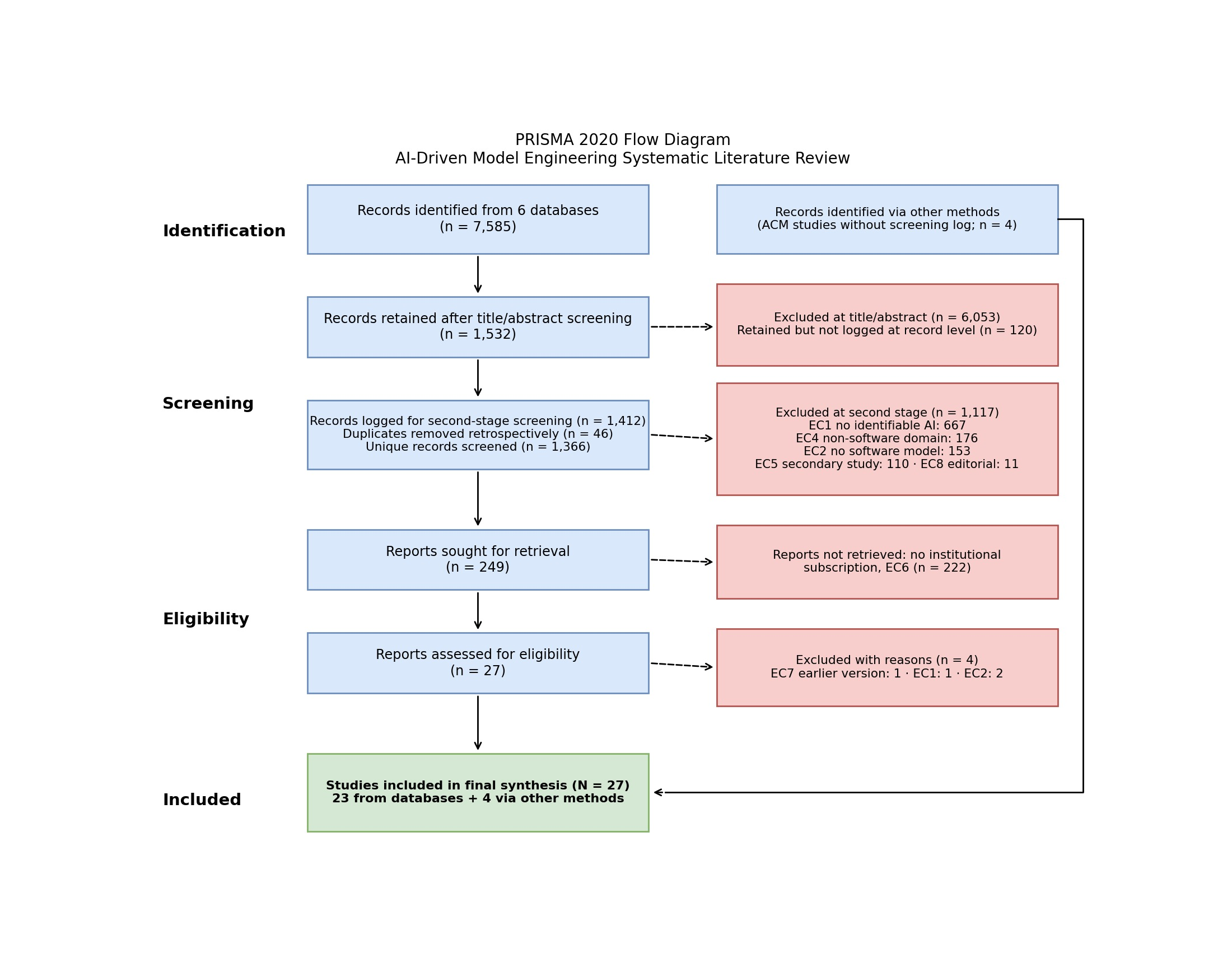

Note. De-duplication was performed retrospectively by title and DOI (Dedup_Log sheet), not as a discrete screening step. Source: PRISMA_Flow sheet, Master Workbook (AI_Driven_Model_Engineering_SLR_Workbook_FINAL_7.xlsx).
The non-retrieval rate (222 of 249, 89.2%) is the most important feature of this flow. The corpus is the accessible subset of eligible work, not the eligible population, and SpringerLink is hit hardest: it returned 3,093 records but supplied two included studies.

3.2 Publication Trends, Sources and Communities (RQ1)
Table 5
Included Studies by Year and Database
Year | n | % |  | Database | n | %
2015 | 1 | 3.7 |  | ScienceDirect | 9 | 33.3
2021 | 2 | 7.4 |  | ACM Digital Library | 6 | 22.2
2023 | 1 | 3.7 |  | Scopus | 4 | 14.8
2024 | 4 | 14.8 |  | Web of Science | 4 | 14.8
2025 | 5 | 18.5 |  | SpringerLink | 2 | 7.4
2026 | 14 | 51.9 |  | IEEE Xplore | 2 | 7.4
Total | 27 | 100.0 |  | Total | 27 | 100.0
Note. Source: Report_Figures sheet, Master Workbook (AI_Driven_Model_Engineering_SLR_Workbook_FINAL_7.xlsx).
Output is recent and steep: 19 of the 27 studies appeared in 2025–2026, and the three pre-2023 studies all use search-based optimization rather than learning (Mansoor et al., 2015; Blasco et al., 2021; Echeverría et al., 2021). The field therefore moved from search to LLMs within about three years, tracking the release of GPT-4-class models. Publication is concentrated: nine studies appeared in the Journal of Systems and Software, which explains the ScienceDirect share; Information and Software Technology has two, and every other venue one.

Author affiliations are mostly European (Spain, Italy, Sweden, Greece, Hungary, the United Kingdom, Austria, France and Luxembourg), with further groups in Canada, Pakistan, China, India and the United States. Three groups contribute more than one study: King's College London on reverse engineering (Siala, 2024; Siala & Lano, 2025, 2026), the Universidad San Jorge group on search-based model engineering (Blasco et al., 2021; Echeverría et al., 2021), and a group at the National University of Sciences and Technology, Pakistan, behind both VeriGen and the blended-modelling framework (Ahmed et al., 2026; Awan et al., 2026). Twenty of the 27 studies address general-purpose software engineering. Domain work is sparse: three studies target safety-critical or embedded systems (Awan et al., 2026; Tahat et al., 2026; Zrelli et al., 2026), two address education (De Bari et al., 2024; Wang et al., 2026), and one each address smart contracts (Ait Hsain et al., 2025) and game development (Blasco et al., 2021). Eighteen studies propose a tool or approach, eight are evaluations or benchmarks, and one is a doctoral vision paper (Siala, 2024). The balance matters for later sections: most of the corpus proposes and demonstrates; fewer studies compare against a strong baseline.

4. Quality Assessment and Risk of Bias

Scores range from 10 (55.6%) to 16 (88.9%) out of 18, with a mean of 71.0%. Nine studies are high quality, seventeen moderate, and one developing (Antal et al., 2024, a short workshop paper). The highest totals go to the reverse-engineering papers from King's College (Siala, 2024; Siala & Lano, 2025), VeriGen (Ahmed et al., 2026) and AGREE-Dog Copilot (Tahat et al., 2026). Siala (2024) is a three-page doctoral-symposium paper, so its score reflects how completely it describes a planned design rather than the strength of tested results. Table 6 shows where the corpus is strong and weak.
Table 6
Mean Quality Score per Criterion (N = 27)
Criterion | Mean | Criterion | Mean | Criterion | Mean
Research clarity | 1.00 | Baseline | 0.61 | Human expertise | 0.26
Independent validation | 1.00 | Semantic fidelity | 0.69 | Experimental rigor | 0.65
Context | 0.96 | Completeness | 0.35 | Statistical analysis | 0.56
Modelling transparency | 0.96 | Cross-view consistency | 0.11 | Reproducibility | 0.65
Dataset quality | 0.96 | AI transparency | 0.81 | Practical relevance | 0.74
Syntactic validity | 0.96 | Threats to validity | 0.96 | Scalability | 0.54
Note. 0 = no, 0.5 = partial, 1 = yes. Source: Quality Assessment sheet, Master Workbook (AI_Driven_Model_Engineering_SLR_Workbook_FINAL_7.xlsx).
Three patterns stand out. First, reporting quality is high where it costs little: aims, context, modelling languages and syntactic checks are almost always described. Second, the criteria that separate a demonstration from evidence are weak. Cross-view consistency (0.11) and completeness (0.35) are rarely measured, so most studies can show that a generated model parses but not that it is whole or consistent with other views. Human expertise (0.26) is the lowest-scoring criterion after consistency: few studies use qualified modelers to judge outputs. Third, rigor is middling, and the means hide how few studies fully meet these criteria. Only four of the 27 studies fully satisfy the statistical-analysis criterion and four of the scalability criterions; most earn partial credit. Six fully satisfy the baseline criterion. Only two fully satisfy human expertise, and none fully satisfy cross-view consistency.
Two risks of bias follow. Performance bias is likely where the same team builds the tool, the dataset and the metric, which is the norm here; only four studies compare against human work (K. Chen et al., 2023; De Bari et al., 2024; Wang et al., 2026; Zrelli et al., 2026), and only one of these compares directly with human modelers solving the same task (De Bari et al., 2024). Publication and version bias also matter results are tied to specific hosted model versions, and Dao et al. (2026) warn that their findings may not replicate as models update. The independent-validation criterion scores 1.00 because every study checks outputs with something other than the generating model, but in most cases that check is a parser or a reference model built by the same authors. In the synthesis, we therefore anchor claims on high-quality studies and state when a finding depends on a single moderate study.

5. Findings

5.1 AI Technologies (RQ2)
LLMs dominate: 23 of the 27 studies use them (Figure 2). GPT-family models are named in 14 studies, followed by Mistral (4), Qwen, DeepSeek and Llama variants (3 each), StarCoder (2) and Gemini (1). Other families are small: agentic or multi-agent designs appear in four studies, search-based and evolutionary optimization in three, and deep learning, multimodal models and neuro-symbolic combinations in two each. No included study uses retrieval-augmented generation, knowledge graphs, or graph neural networks as its main technique. The technology question has therefore become an LLM question and claims about 'AI techniques' in general rest on a thin base outside LLMs.
Figure 2
AI Technologies Across the 27 Included Studies
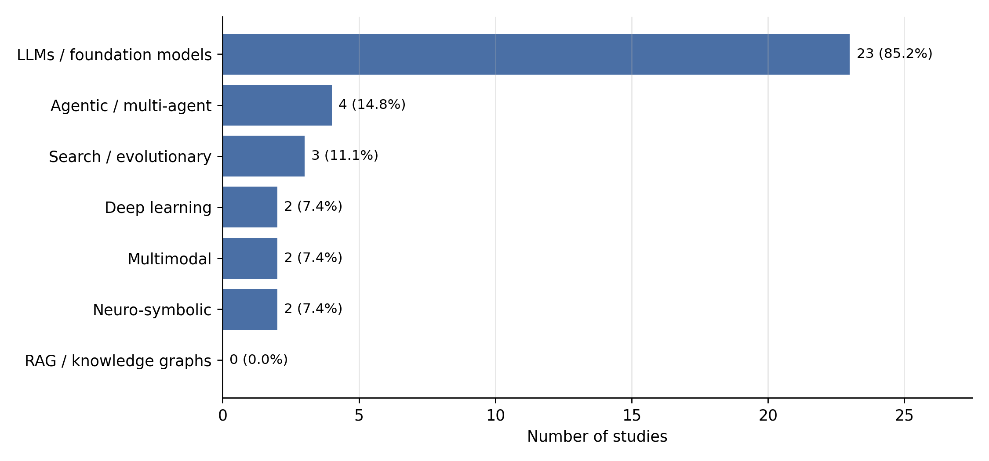
Note. Multi-label coding; a study can appear in more than one category. Source: Study_Coding sheet, Master Workbook (AI_Driven_Model_Engineering_SLR_Workbook_FINAL_7.xlsx).
How LLMs are adapted matters more than which LLM is used. Prompting is the default: K. Chen et al. (2023) compared zero-shot, few-shot and chain-of-thought prompting on ten domain-modelling problems, and Lamas et al. (2026) combine grammar prompting with few-shot examples. Fine-tuning is rarer but produces the largest gains where it is used. Siala and Lano (2025) fine-tuned Mistral-7B with QLoRA to abstract class diagrams from Java and raised accuracy from 50.7% for the base model to 99.3%; Zrelli et al. (2026) found a fine-tuned Mistral the most accurate of three approaches to translating requirements into CTL. Prompt-only use of large proprietary models is cheaper to set up but leaves correctness to chance, which is why the strongest designs wrap the model in checks.

The proprietary-versus-open contrast named in section 2.7 has one direct test. Dao et al. (2026) ran GPT-5 and Gemini 2.5 against the open-weight Qwen3 and DeepSeek V3 under one protocol: Gemini was the most consistent across runs, Qwen3 the most variable, DeepSeek V3 preserved meaning but sometimes produced unparsable output, and GPT-5 often detected a change without propagating it.
No model family won on every measure. Elsewhere open models appear where teams fine-tune, as in the Mistral studies above and the four open LLMs in MoRe (R. Chen et al., 2026). Agent designs remain early: RQ2DSL uses a single GPT-4 agent that repairs its own grammar using TextX error messages (Tsampouris et al., 2025), and Ali et al. (2026) coordinate several agents under metamodel constraints, but no study compares single- and multi-agent versions of the same task.

5.2 Lifecycle Coverage (RQ3)
AI is concentrated at the two ends of the lifecycle (Figure 3). Requirements-to-model generation is the best-covered stage with seven studies, followed by model-to-code synthesis (six) and requirements of understanding (five). These stages share a checkable input-output pair: a requirement and a model, or a model and compilable code. The middle of the lifecycle is thinner. Quality assurance, repair and code-to-model extraction have three studies each; model transformation has two, and model completion rests on a single study (Ben Chaaben et al., 2026).
Figure 3
Evidence Coverage Across the Twelve Lifecycle Stages
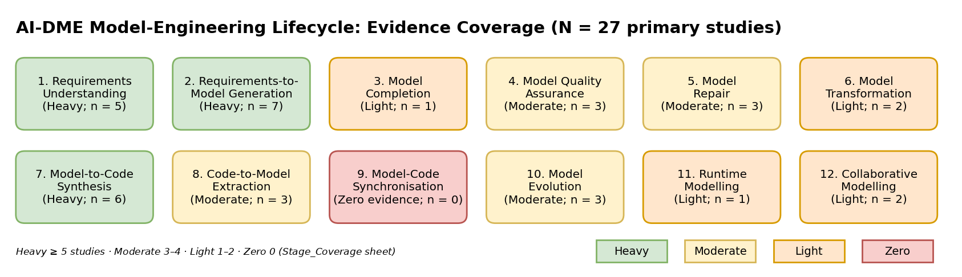
Note. Heavy ≥ 5 studies, moderate 3–4, light 1–2, zero 0. Source: Stage_Coverage sheet, Master Workbook (AI_Driven_Model_Engineering_SLR_Workbook_FINAL_7.xlsx).
The late lifecycle is where the brief's vision of continuous engineering meets the least evidence. No study addresses model-code synchronization. Model evolution has three studies, but they are a benchmark of LLM co-evolution (Dao et al., 2026) and two search-based studies on feature location and model merging (Echeverría et al., 2021; Mansoor et al., 2015); none uses runtime data. Runtime modelling rests on one architecture study whose AI components are not individually evaluated (Eramo et al., 2024), and collaborative modelling on two (Awan et al., 2026; Mansoor et al., 2015). AI-DME is today a design-time practice: it generates and extracts models but does not keep them aligned once code starts to change.

5.3 Modelling Languages and Artefacts (RQ4)
Table 7
Modelling Languages and Artefacts Supported
Artefact class | Languages | AI-supported activities | Supporting studies
Structural | UML class, domain models, Ecore | Generation, completion, extraction | K. Chen et al. (2023); Ben Chaaben et al. (2026); Alaswad et al. (2026); R. Chen et al. (2026); Siala & Lano (2026)
Behavioural and process | BPMN 2.0 | Process generation | Boujmil & Chebil (2025)
Interaction | UML sequence diagrams | Generation, assessment | Ahmed et al. (2026); Wang et al. (2026)
Architectural and embedded | EAST-ADL, AADL | Collaborative modelling, verified repair | Awan et al. (2026); Tahat et al. (2026)
Formal | OCL, Alloy, AGREE, CTL | Constraint generation, formalization, proof | Delgado et al. (2026); Siala & Lano (2026); Tahat et al. (2026); Zrelli et al. (2026)
Domain-specific | TextX grammars, DSL instances, smart-contract DSMLs, game DSML | Grammar and instance generation | Tsampouris et al. (2025); Lamas et al. (2026); Ait Hsain et al. (2025); Blasco et al. (2021)
Implementation | Java, Python, Solidity | Model-to-code, code-to-model | Antal et al. (2024); Ahmed et al. (2026); Siala & Lano (2025, 2026)
Note. Source: Data Extraction sheet (Modelling Language field), Master Workbook (AI_Driven_Model_Engineering_SLR_Workbook_FINAL_7.xlsx).
UML class and domain models dominate, as the brief anticipated. Behavioural models are much weaker: BPMN appears in one generation study, and no study generates UML state machines or activity diagrams and evaluates them. Sequence diagrams appear in VeriGen (Ahmed et al., 2026) and in grading (Wang et al., 2026). SysML is absent from the included corpus; SysML generation work found by the search could not be retrieved. Formal languages are more common than expected, and they matter: three of the five studies that reach formal validation do so because the output itself is formal (Delgado et al., 2026; Tahat et al., 2026; Zrelli et al., 2026). Delgado et al. (2026) also show that LLMs generate Python more reliably than OCL or Alloy, which suggests that constraint languages with little training data remain a weak point.

5.4 From Requirements to Models (RQ5)
The requirements-to-model studies follow a common pipeline: interpret the text, build an intermediate structure, generate the model, then check it. They differ in how much structure they add before generation, and that difference explains much of the variation in results (Table 8).
Table 8
Comparison of Requirements-to-Model Approaches
Study | Technique | Intermediate structure | Validation | Reported result | QA
K. Chen et al. (2023) | GPT-3.5/4, zero-, few-shot, CoT | None | Expert reference models | F1 0.76 classes, 0.34 relationships | Mod.
De Bari et al. (2024) | GPT-4 on 20 exercises | None | Human solutions, reference | 4.85 vs 1.75 semantic errors (LLM vs human) | Mod.
Boujmil & Chebil (2025) | spaCy + GPT-4 for BPMN | NLP dependency parse | Gold-standard comparison | Fewer spurious gateways than pure LLM or pure NLP | Mod.
Alaswad et al. (2026) | Custom Seq2AST transformer | Abstract syntax tree | AST reconstruction, F1 | F1 89.9% vs 85.3% for base Seq2AST | Mod.
R. Chen et al. (2026) | Four open LLMs + rule scanner | Draft model | Rule-based checker, semantic matcher | F1 above both baselines for most LLMs | Mod.
Ahmed et al. (2026) | GPT-4 + verifier-optimizer | RUPP structured templates | Deterministic verifier loop | Class accuracy 56.2% to 87.8% | High
Note. QA = quality tier from the Quality Assessment sheet. Source: Data Extraction sheet, Master Workbook (AI_Driven_Model_Engineering_SLR_Workbook_FINAL_7.xlsx).
Two findings stand out. Unstructured prompting gives precise but incomplete models: K. Chen et al. (2023) report a class F1 of 0.76 but only 0.34 for relationships, and De Bari et al. (2024) found LLM solutions made almost three times as many semantic errors as human ones. Adding structure helps at every point where it has been tried: a parse tree before generation (Boujmil & Chebil, 2025), an abstract syntax tree as the output format (Alaswad et al., 2026), a rule-based scanner after generation (R. Chen et al., 2026) and structured requirement templates with a verifier loop (Ahmed et al., 2026). The largest single gain in the corpus comes from the most structured design. The caveat is that each approach is tested on its own dataset, so the gains are directionally consistent but not directly comparable.
Multimodal input is rare. GPT-4 Vision recovered on average 88.25% of elements when generating Java from UML images, but performance fell on multi-class diagrams (Antal et al., 2024), and Wang et al. (2026) used GPT-4 to grade 120 student diagrams. No study generates behavioral or architectural models from sketches or other visual requirements.

5.5 Roles of AI (RQ6)
Table 9
Roles Performed by AI and Their Evidence
Role | What the AI does | Supporting studies | Strength
Requirement interpreter | Extracts entities, relations and constraints from text | Boujmil & Chebil (2025); Ahmed et al. (2026); Zrelli et al. (2026); Shimangaud et al. (2026) | Moderate
Model generator | Produces class, domain or content models | K. Chen et al. (2023); De Bari et al. (2024); Blasco et al. (2021); Alaswad et al. (2026); R. Chen et al. (2026) | Heavy
Recommender | Suggests missing classes and attributes | Ben Chaaben et al. (2026) | Light
Critic and validator | Flags defects and misalignments | Wang et al. (2026); Shimangaud et al. (2026); Delgado et al. (2026) | Moderate
Repair assistant | Fixes models using verifier feedback | Ahmed et al. (2026); R. Chen et al. (2026); Tahat et al. (2026) | Moderate
Transformation synthesizer | Maps between representations | Dao et al. (2026); Zrelli et al. (2026) | Light
Code generator | Turns models or DSL specifications into code | Antal et al. (2024); Ait Hsain et al. (2025); Ahmed et al. (2026); Lamas et al. (2026) | Moderate
Reverse-engineering assistant | Abstracts UML and OCL from code | Siala (2024); Siala & Lano (2025, 2026) | Moderate
Consistency monitor | Checks alignment, merges or co-evolves artefacts | Mansoor et al. (2015); Awan et al. (2026); Dao et al. (2026) | Light
Orchestrator | Coordinates several AI components | Tsampouris et al. (2025); Eramo et al. (2024); Ali et al. (2026) | Light
Note. Source: Data Extraction (Model-Engineering Stage/Task) and Study_Coding sheets, Master Workbook (AI_Driven_Model_Engineering_SLR_Workbook_FINAL_7.xlsx).
Generation is the best-evidenced role, and generation plus repair is where the field is heading. Roles that the brief treats as central to continuous engineering, namely recommendation, consistency monitoring and orchestration, rest on one to three studies each. Ben Chaaben et al. (2026) give the only controlled user study of AI recommendation (30 participants) and report faster modelling alongside a loss of diversity in the resulting models, a trade-off no other study measures. Roles are increasingly chained: VeriGen interprets, generates, verifies, repairs and generates code in one pipeline (Ahmed et al., 2026). A role should therefore be classified by the engineering task it performs, not by the AI technology behind it.

5.6 Levels of Automation (RQ7)
Mapping each study to the brief's six-level continuum gives a clear center of gravity (Table 13 in section 6.2). Eleven studies (40.7%) reach Level 4: the AI generates substantial models or transformations, but a human approves them. Six studies each sit at Level 2 (assistive) and Level 3 (interactive co-modelling). Four reach Level 5, verifier-guided autonomy: VeriGen (Ahmed et al., 2026), SCEditor-Web (Ait Hsain et al., 2025), AGREE-Dog Copilot (Tahat et al., 2026) and MoRe (R. Chen et al., 2026). No study reaches Level 6, and none sits at Level 1, since every included study uses AI by definition.
The most important maturity finding is how Level 5 is reached. All four studies place a deterministic component between the model and acceptance: a design verifier, a smart-contract compiler and static analyzer, an SMT-based model checker, or a rule scanner. Because Level 5 is defined by this feedback loop, the fact that all four have one is a consequence of the definition, not a finding. The finding is what the loop adds: the one study that reports accuracy with and without it shows class-diagram accuracy rising from 56.2% to 87.8% (Ahmed et al., 2026, p. 25).

5.7 Evaluation of AI-Generated Models (RQ8)
Evaluation practice is shallow and uneven. Twelve studies check syntactic validity and eleven compare outputs with a reference model, but only seven measure structural completeness or consistency, six involve human experts or users, five check formal conformance or traceability, and five examine scale or reproducibility (Evaluation_Hierarchy sheet). Semantic fidelity is measured in different ways, including exact element matching, semantic matching, distance to a reference solution, and correlation with a human grader, so numbers from different studies cannot be compared directly. The expected gap in the brief is confirmed: syntactic validity is often used as a stand-in for correctness. Cross-view consistency is the most neglected quality attribute (quality criterion mean 0.11), and requirements traceability is measured explicitly only where the pipeline carries structured requirements through to code (Ahmed et al., 2026) or aligns text with models (Shimangaud et al., 2026).

5.8 Validation Mechanisms (RQ9)
Table 10
Deterministic and Human Validation Mechanisms
Mechanism | Examples in the corpus | What it guarantees | Studies
Grammar and syntax checking | TextX tools, PlantUML, javac, solc | Well-formedness only | Tsampouris et al. (2025); Antal et al. (2024); Ait Hsain et al. (2025)
Metamodel and rule scanning | Ecore rules, anti-pattern scanner | Structural conformance | R. Chen et al. (2026); Siala & Lano (2025)
Constraint execution | USE (OCL), Alloy Analyzer | Constraint satisfaction | Delgado et al. (2026)
Static analysis | Slither for smart contracts | Known vulnerability patterns | Ait Hsain et al. (2025)
Model checking and proof | AGREE with JKind k-induction; NuSMV for CTL | Property satisfaction | Tahat et al. (2026); Zrelli et al. (2026)
Reference comparison | Expert or benchmark reference models | Similarity to one accepted answer | K. Chen et al. (2023); R. Chen et al. (2026); Siala & Lano (2026)
Human review | User studies, instructor grading | Usefulness and judged quality | Ben Chaaben et al. (2026); Wang et al. (2026); Lamas et al. (2026)
LLM as judge | A second LLM checks the output | Weak; not independent | Morales et al. (2025)
Note. Source: Data Extraction sheet (Validation Mechanism field), Master Workbook (AI_Driven_Model_Engineering_SLR_Workbook_FINAL_7.xlsx).
The mechanisms form a ladder of assurance. Parsers and compilers are cheap and universal but guarantee only form. Formal tools guarantee much more but need formal targets and expertise: AGREE-Dog Copilot proves AADL contracts and was evaluated on 13 fault-injection scenarios (Tahat et al., 2026), a strong but narrow result. Between them sits the most common practice, comparison with a reference model, whose value depends on the reference; R. Chen et al. (2026) note that they had no inter-annotator agreement for theirs. Using an LLM to judge an LLM appears in one prompt-engineering framework (Morales et al., 2025) and gives the weakest assurance in the corpus. The pattern that recurs across the strongest studies is a closed loop: the checker classifies elements as correct, incorrect, missing or extra, and those diagnoses are fed back as targeted repair prompts (Ahmed et al., 2026; Tsampouris et al., 2025, who report a 93.4% grammar validation rate after up to ten repair iterations).

5.9 Transformations (RQ10)
Model-to-code is the most active pipeline. VeriGen, GPT-4 Vision and SCEditor-Web produce Java or Solidity that is checked by compilation and, for smart contracts, static analysis (Ahmed et al., 2026; Antal et al., 2024; Ait Hsain et al., 2025); DSL-Xpert 2.0 generates DSL instances from grammar prompts (Lamas et al., 2026). Code-to-model is served by one research line that has matured across three papers: a doctoral proposal (Siala, 2024), a fine-tuned Mistral-7B that abstracts Java class diagrams at 99.3% accuracy (Siala & Lano, 2025), and an extension to Python and OCL with recall 0.921 and precision 0.976, which falls to recall 0.834 on a 17,640-line package (Siala & Lano, 2026). The drop with scale is the most useful number in this line because it is the only reported test of an LLM-based tool on a large code base; the large-scale results from Blasco et al. (2021) and Echeverría et al. (2021) come from search-based methods.

Model-to-model transformation is the weak pipeline. Dao et al. (2026) test whether four LLMs propagate edits between class models and relational schemas and back: all handle small edits, but structural reorganization such as splitting or merging classes fails, and GPT-5 often detects a change without propagating it coherently. Zrelli et al. (2026) translate requirements into CTL. No study generates or refines transformation rules in ATL or QVT, which the brief lists as a core AI-DME activity. Model-to-text appears only as explanatory change logs in collaborative modelling (Awan et al., 2026). Search-based methods remain competitive where the task is optimization: a hybrid evolutionary and hill-climbing strategy performed best across 1,895 industrial feature-location problems (Echeverría et al., 2021), and multi-objective merging matched existing approaches on conflict minimization across seven systems (Mansoor et al., 2015).

5.10 Benefits Compared With Traditional MDE (RQ11)
Table 11
Effect Direction Compared With Manual or Rule-Based MDE
Dimension | Direction | Strength | Key evidence
Productivity | Improves | Moderate | About 20% shorter task time with AI assistance, 30 participants (Ben Chaaben et al., 2026); 5 hours unattended against 10 months of developer work for game models (Blasco et al., 2021)
Model correctness | Mixed | Moderate | Precise but incomplete without checks (K. Chen et al., 2023; De Bari et al., 2024); large gains with verification (Ahmed et al., 2026)
Code quality | Mixed | Moderate | Compilable output (Ait Hsain et al., 2025) but weaker on constraint languages (Delgado et al., 2026) and complex diagrams (Antal et al., 2024)
Maintainability | Not measured | None | No study measures maintainability of generated models or code
Platform adaptability | Improves | Light | New DSLs and languages with little data (Lamas et al., 2026; Siala & Lano, 2026)
Cost | Unclear | Weak | Token and repair-loop cost reported qualitatively (Ahmed et al., 2026); energy treated as an objective in one study (Ali et al., 2026)
Note. Effect-direction analysis; no pooled effect sizes. Source: Data Extraction sheet, Master Workbook (AI_Driven_Model_Engineering_SLR_Workbook_FINAL_7.xlsx).
The honest answer to RQ11 depends on the axis. AI clearly improves input coverage and, in the one controlled study, speed. On correctness it improves over nothing, not over experts: De Bari et al. (2024) is the only direct comparison with human modelers and the humans win. Few studies compare with a rule-based MDE baseline at all; Siala (2024) positions against MoDisco and Blasco et al. (2021) against random search and developer-made models, but most compare LLM with LLM or prompt with prompt. Maintainability is unmeasured, and cost is reported qualitatively, so the claim that AI-DME is cheaper than conventional MDE is not supported by this corpus.

5.11 Risks (RQ12)
Hallucination is the best-documented risk, and the reason for verifier loops to exist. MoRe catalogues recurring defect types, led by unnecessary structural features (34.1% of defects) and inheritance misused as reference (18.2%) (R. Chen et al., 2026). Nondeterminism is the next: Dao et al. (2026) report run-to-run variance across four LLMs and treat it as a reliability signal, and Shimangaud et al. (2026) repeat LLM queries to dampen it. Silent incompleteness, where a model looks right but misses relationships, is a quiet risk that low recall makes likely (K. Chen et al., 2023). Automation bias is suggested by the loss of solution diversity under AI assistance (Ben Chaaben et al., 2026). Privacy is addressed in one study through on-device inference (Awan et al., 2026). Model drift, intellectual property and bias receive little empirical treatment; Ali et al. (2026) are the only authors to measure bias between agents. The recurring mitigation is the same in every strong study: do not trust the LLM alone and put a deterministic check or a human approval step after it.

5.12 Adoption Factors (RQ13)
Four factors recur. Integration with existing tool chains matters more than model power: the tools that reached users sit inside Eclipse-based environments or IDE plug-ins (Ben Chaaben et al., 2026; Awan et al., 2026; Morales et al., 2025). Standards alignment is a precondition in regulated domains, and it is delivered by MDE infrastructure such as EAST-ADL tooling and AGREE contracts rather than by the LLM (Awan et al., 2026; Tahat et al., 2026). Scalability is ambiguous: collaboration scaled to 100 concurrent users with 15–30 ms latency (Awan et al., 2026), but generation quality falls with model size (Siala & Lano, 2026), and these are different axes. Governance is the fourth: approval gates, provenance and audit logs appear in every study with industrial partners (Awan et al., 2026; Eramo et al., 2024). Organizational readiness is not studied directly. No included study surveys adopting organizations or measures training needs; the nearest evidence is the formal-methods expertise that AGREE-Dog Copilot requires of its users (Tahat et al., 2026).

5.13 Reproducibility, Generalizability and Deployment (RQ14)
Table 12
Real-World Evidence and Reproducibility Assets
Study | Real-world evidence | Assets | Main caveat
Eramo et al. (2024) | 10 industrial case studies, 54 solutions (AIDOaRt) | Architecture described | Partners in the project; feasibility, not performance
Echeverría et al. (2021) | 1,895 problems from 40 industrial product lines | Measures described; data proprietary | Two domains; pre-LLM
Blasco et al. (2021) | Commercial game, models with over 1,000 elements | Implementation released | Single game and DSML
Awan et al. (2026) | Volvo wiper case, EAST-ADL, up to 100 users | Web components open | Single case; desktop tool proprietary
Tahat et al. (2026) | Avionics case studies, 13 fault scenarios | OSATE plug-ins | Needs formal-methods experts
Ben Chaaben et al. (2026) | 30-participant user study | Prototype tool | Controlled tasks
K. Chen et al. (2023); R. Chen et al. (2026) | 10 and 30 academic problems | Datasets and prompts public | Textbook scale
Note. Source: Data Extraction sheet (Industrial Evidence and Reproducibility Assets fields), Master Workbook (AI_Driven_Model_Engineering_SLR_Workbook_FINAL_7.xlsx).
Real-world evidence is thin and concentrated: five studies use industrial data or partners, each with one partner or one domain. Three of the five are pre-LLM or architecture-level studies, so the LLM-based tools with the best accuracy figures have mostly not left the laboratory. Reproducibility is partial: eight studies fully satisfy the reproducibility criterion, and nineteen partly satisfy it, and prompts; model versions, temperature and cost are reported inconsistently. Dao et al. (2026) are a positive exception, archiving prompts, outputs and model identifiers and warning that hosted models change. Generalizability is weak: most accuracy figures come from textbook-scale problems and do not transfer to multi-view industrial systems.

6. Scholarly Contributions (RQ15)

6.1 Multidimensional Taxonomy
The taxonomy (Figure 4) has seven dimensions, derived from the brief's framework and populated from the coded corpus: lifecycle stage, input artefact, output artefact, AI technology, AI role, validation mechanism and quality attribute. The dimensions answer different questions (where, from what, to what, with which technique, doing what, checked how, judged by which quality), so a study can be placed on each independently. The counts show that taxonomy is not just a list of categories. Several cells are empty or nearly so: synchronization, retrieval-augmented and knowledge-graph techniques, and state-machine outputs. These empty cells are the research gaps in section 6.6.
Figure 4
Multidimensional Taxonomy of AI-Driven Model Engineering
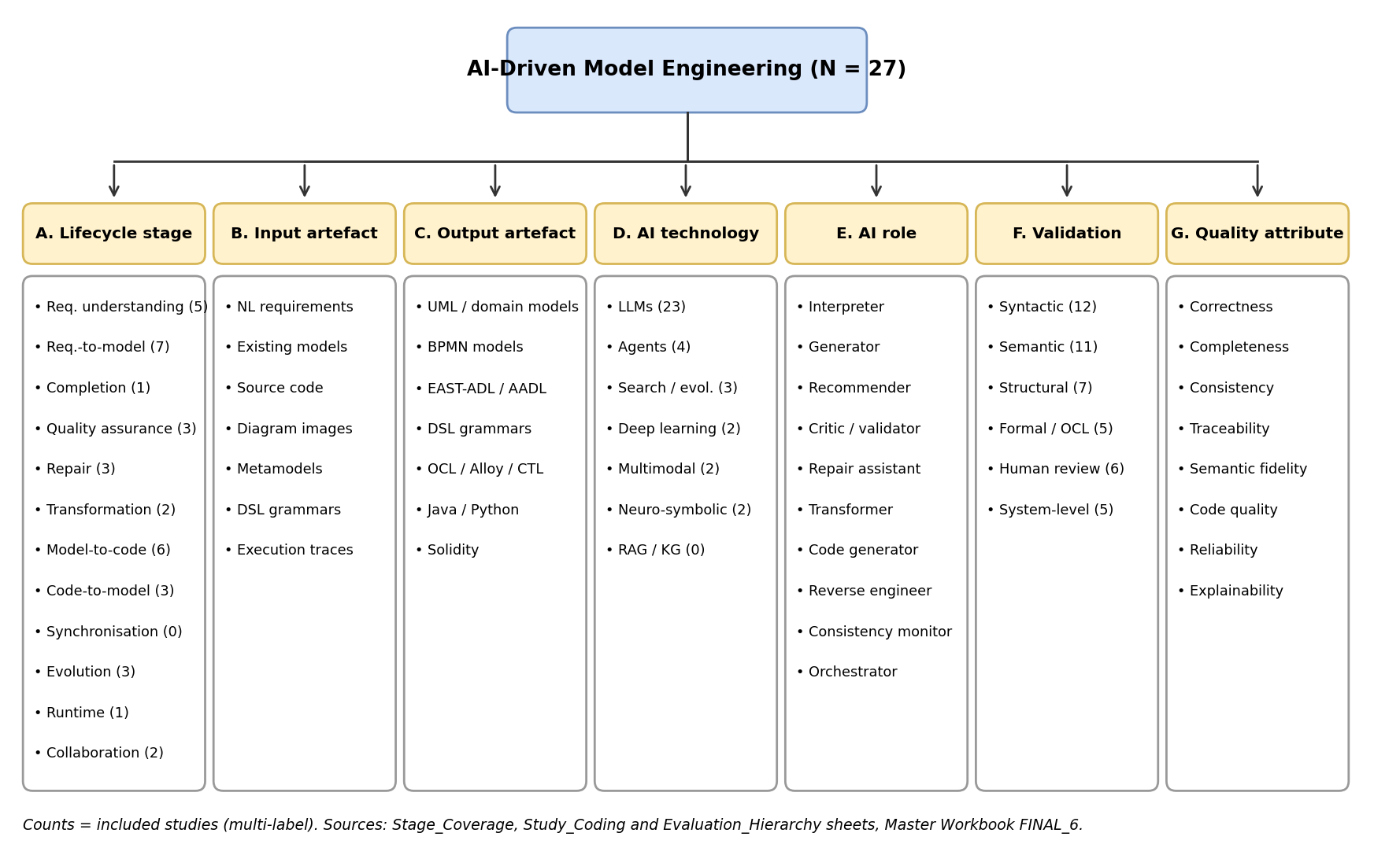
Note. Counts are included studies (multi-label). Source: Stage_Coverage, Study_Coding and Evaluation_Hierarchy sheets, Master Workbook (AI_Driven_Model_Engineering_SLR_Workbook_FINAL_7.xlsx).

6.2 Automation Maturity Model
Table 13
AI-DME Automation Maturity Model With Corpus Evidence
Level | Definition and entry condition | Human role | Studies (n, %)
L1 Manual | No substantive AI support. Entry: no AI component | Author and verifier | 0 (baseline)
L2 Assistive | AI explains, recommends, or assesses. Entry: AI output is advice; a human authors the model | Accepts or rejects suggestions | 6 (22.2%): Siala (2024); K. Chen et al. (2023); De Bari et al. (2024); Wang et al. (2026); Shimangaud et al. (2026); Echeverría et al. (2021)
L3 Interactive | Human and AI refine models together. Entry: human and AI edit the same artefact in turns | Co-author | 6 (22.2%): Delgado et al. (2026); Ben Chaaben et al. (2026); Awan et al. (2026); Morales et al. (2025); Lamas et al. (2026); Zrelli et al. (2026)
L4 Semi-autonomous | AI produces substantial models; human approves. Entry: complete model output with no automatic checker feedback | Approver | 11 (40.7%): Tsampouris et al. (2025); Boujmil & Chebil (2025); Antal et al. (2024); Siala & Lano (2025, 2026); Alaswad et al. (2026); Blasco et al. (2021); Ali et al. (2026); Dao et al. (2026); Eramo et al. (2024); Mansoor et al. (2015)
L5 Verifier-guided | AI generates, checks, diagnoses, and repairs. Entry: deterministic diagnoses fed back to the generator automatically | Governor of the loop | 4 (14.8%): Ahmed et al. (2026); Ait Hsain et al. (2025); Tahat et al. (2026); R. Chen et al. (2026)
L6 Continuous adaptive | Agents keep requirements, models, code, and runtime aligned. Entry: change or runtime data triggers model updates without a human starting them | Supervisor of exceptions | 0
Note. Levels from the assessment brief; entry conditions added by this review. Source: Maturity_Model sheet, Master Workbook (AI_Driven_Model_Engineering_SLR_Workbook_FINAL_7.xlsx).
The model adds two things to the brief's continuum. The first is an entry condition for each level that can be checked in a paper (Table 13); for example, Level 5 requires a deterministic checker whose diagnoses are fed back to the generator, which separates it from Level 4 tools that generate and hand over. The second is the finding that levels are not a ranking of quality. Level 2 studies include some of the most rigorous evaluations (K. Chen et al., 2023), while several Level 4 tools have never been compared with a baseline. Maturity describes autonomy; the evaluation hierarchy below describes assurance, and both are needed to judge a tool.

6.3 Evaluation Hierarchy
Table 14
Seven-Level Evaluation and Assurance Hierarchy
Level | Question answered | Typical evidence | Studies (n)
0 Unchecked | Was the output inspected at all? | Raw generation | None in corpus
1 Syntactic | Does it parse and compile? | Grammar, AST, compiler checks | 12
2 Semantic | Does it mean what the source means? | Precision, recall, F1 against a reference | 11
3 Structural | Is it complete and internally consistent? | Missing elements, multiplicities, cross-view checks | 7
4 Formal | Does it satisfy stated constraints and trace requirements? | OCL execution, SMT proof, model checking | 5
5 Human | Do qualified people judge it useful, and correct? | User studies, expert assessment | 6
6 System | Does it hold at scale, repeatedly and in industry? | Large models, repeated runs, industrial data | 5
Note. Level 0 added as the baseline; Levels 1–6 correspond to the tiers in the Evaluation_Hierarchy sheet, Master Workbook (AI_Driven_Model_Engineering_SLR_Workbook_FINAL_7.xlsx).
The hierarchy orders evaluation by the strength of the correctness to claim it supports. Its main use is to stop weak evidence from being read as strong: a study that reaches only Level 1 has shown that a model is well-formed, not that it is right. The corpus plateaus at Levels 1 and 2. Level 4 of the hierarchy is reached only where a formal or constraint tool is part of the pipeline, which links the hierarchy to the maturity model: three of the five Level 4 studies are also at maturity Level 5.

6.4 Conceptual Framework
The framework (Figure 5) explains the pattern the review keeps finding. AI intervention, meaning the model of family, prompting, fine-tuning, retrieval and agent design, is the independent variable. Engineering outcomes (syntactic validity, semantic fidelity, completeness, consistency, and time saved) are the dependent variable. Transparency and grounding, meaning intermediate representations, metamodels, deterministic verification and human review, mediate the relationship. Context moderates it: language strictness, domain complexity, system scale and team expertise.
Figure 5
Conceptual Framework for AI-Driven Model Engineering
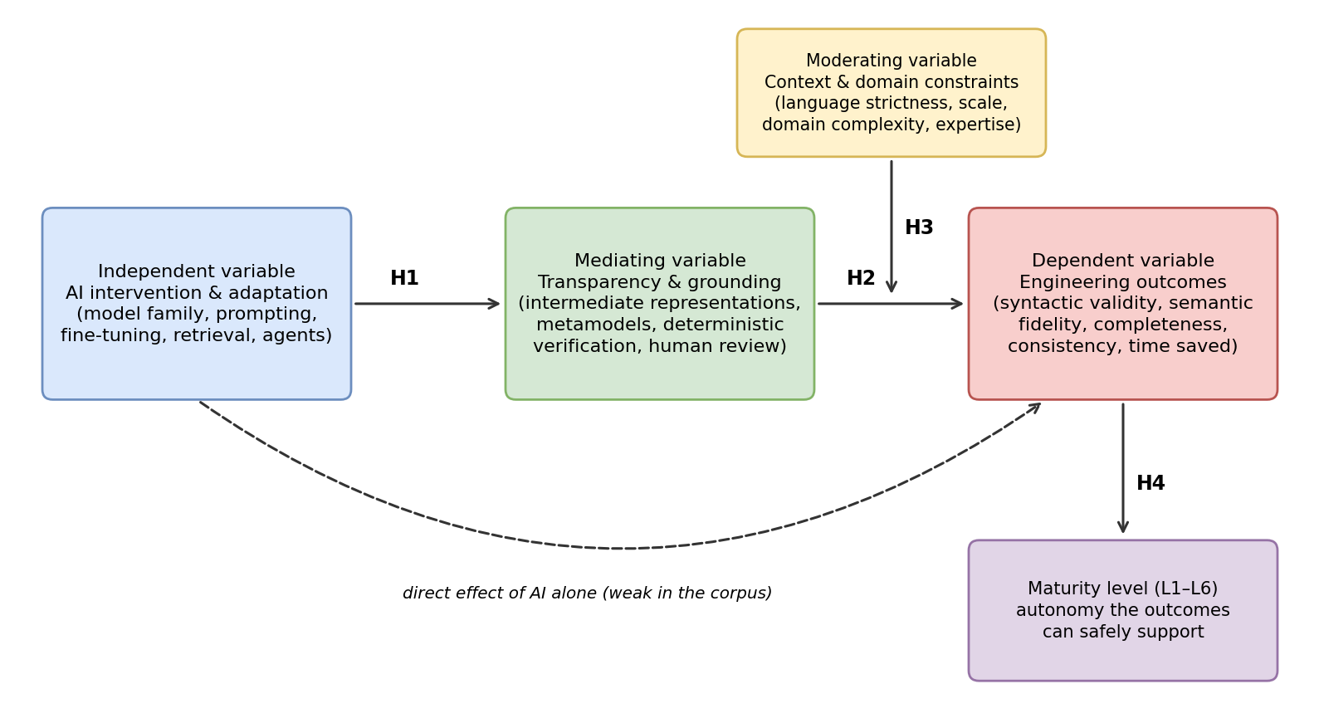
Note. H1–H4 are propositions supported by the synthesis. Source: Conceptual_Framework sheet, Master Workbook (AI_Driven_Model_Engineering_SLR_Workbook_FINAL_7.xlsx).
Four propositions follow the evidence. H1: richer grounding follows from deliberate design choices, such as structured templates or AST outputs, rather than from larger models (Ahmed et al., 2026; Alaswad et al., 2026). H2: grounding improves outcomes; where a study reports results with and without a verifier or structured intermediate representation, the grounded version performs better (Ahmed et al., 2026; Alaswad et al., 2026; R. Chen et al., 2026). H3: context moderate outcomes; quality falls with system size (Siala & Lano, 2026) and with constraint languages that have little training data (Delgado et al., 2026). H4: outcome quality limits the autonomy that can safely be granted, which is why no study reaches Level 6. The direct path from AI to outcomes, without mediation, is weak in the corpus.

6.5 Verifier-Guided Reference Architecture
The reference architecture (Figure 6) turns the framework into a design with five layers. The specification layer structures requirements before generation, for example with RUPP templates (Ahmed et al., 2026) or NLP parsing (Boujmil & Chebil, 2025). The generation layer holds the LLM or agents and can use prompted, fine-tuned or open models. The verification layer is deterministic and never an LLM: parsers, compilers, OCL execution, static analysis and model checking. Its diagnoses flow back to the generator in a bounded repair loop. The traceability layer keeps requirement-to-model links and explainable change logs (Awan et al., 2026; Siala & Lano, 2026). The governance layer spans all four and is where a named human approves, resolves conflicts and signs off. Five studies contribute governance elements (Reference_Architecture sheet); role-based access and audit trails are most developed in Awan et al. (2026) and Eramo et al. (2024).
Figure 6
Verifier-Guided Reference Architecture
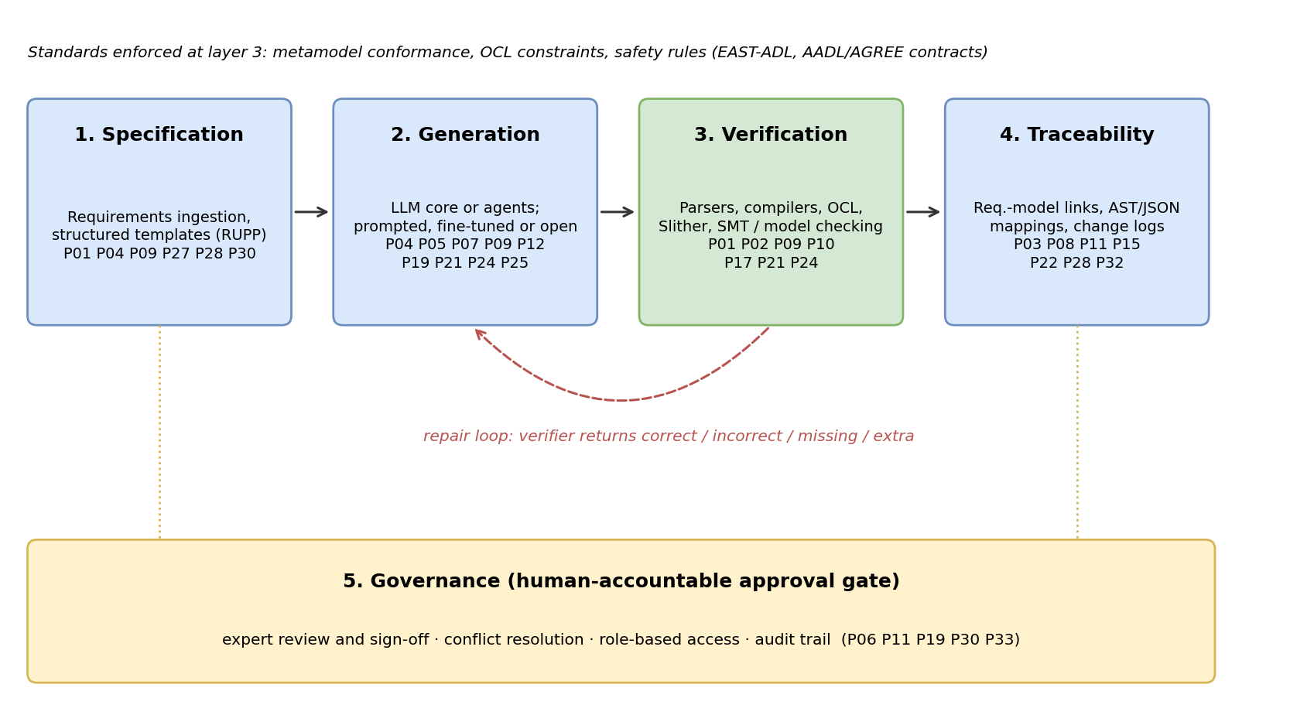
Note. Study identifiers show evidence for each layer (Appendix A). Source: Reference_Architecture sheet, Master Workbook (AI_Driven_Model_Engineering_SLR_Workbook_FINAL_7.xlsx).
The architecture is standards-compliant because conformance is enforced in the verification layer, traceable because links are kept as first-class artefacts, and human-accountable because acceptance is a governed decision rather than a model output. Every layer is supported by at least five included studies, but no single study implements all five. Building and evaluating the complete loop is the first item on the agenda below.

6.6 Gap Matrix
Table 15
Gap Matrix: Expected Research Gaps Against the Evidence
Expected gap (brief) | Coverage in corpus | Status
Overemphasis on class diagrams | Structural models dominate generation (Stage 2, 7 studies); no state-machine generation | Confirmed
Limited behavioral, architectural and runtime models | BPMN in 1 study; EAST-ADL and AADL in 2; runtime in 1 partial | Confirmed
Syntax used as a substitute for semantics | Level 1 checks in 12 studies; formal checks in 5 | Confirmed
Weak cross-diagram consistency and traceability | Consistency criterion mean 0.11; traceability measured in 2 studies | Confirmed
Limited integration with OCL, formal constraints, model checking | 5 studies reach evaluation Level 4; 3 of them are at maturity Level 5 | Partly addressed
Insufficient evidence on transformation correctness and synchronization | M2M in 2 studies; synchronization in 0 | Confirmed
Reliance on textbook examples | Most accuracy results on 10–30 academic problems | Confirmed
Lack of standard benchmarks and industrial datasets | Every study uses its own dataset; 5 with industrial data | Confirmed
Inadequate comparison with experts and MDE tools | 4 studies compare with human work, 1 directly with human modelers; 2 rule-based or search baselines | Confirmed
Weak reporting of prompts, versions, variability, cost | Reproducibility mean 0.65; cost reported qualitatively | Partly addressed
Limited uncertainty, explainability, governance | Run-to-run variance in 2 studies; XAI logs in 1; governance elements in 5, approval gates with audit trails in 2 | Confirmed
Safety-critical, regulated and multilingual settings | 3 safety-critical studies; no multilingual study | Confirmed
Continuous runtime evolution and adaptation | No study at Level 6; runtime modelling 1 partial study | Confirmed
Note. Gaps from section 3 of the brief. Source: Stage_Coverage, Quality Assessment and Evaluation_Hierarchy sheets, Master Workbook (AI_Driven_Model_Engineering_SLR_Workbook_FINAL_7.xlsx).
Table 15a crosses the two dimensions most often used to describe the field, AI technique and task, to show where the empty cells lie. Outside LLMs almost every cell is empty or holds one study, and knowledge-grounded techniques are absent from every task.
Table 15a
Gap Matrix: AI Technique by Model-Engineering Task (Studies per Cell)
Technique | Req. understanding | Model generation | Completion and QA | Repair | Transformation and reverse eng. | Model-to-code | Runtime and evolution
LLMs / Foundation Models | 6 | 8 | 7 | 4 | 6 | 5 | 2
Specialized ML / Evolutionary | 0 | 1 | 0 | 0 | 0 | 0 | 2
Deep Learning (Seq2Seq / Seq2AST / CNN) | 1 | 1 | 0 | 0 | 1 | 0 | 0
Multimodal Foundation Models | 0 | 0 | 1 | 0 | 0 | 1 | 0
Knowledge Graphs, RAG & GNNs | 0 | 0 | 0 | 0 | 0 | 0 | 0
Single & Multi-Agent Systems | 3 | 3 | 1 | 1 | 0 | 1 | 1
Neuro-Symbolic AI | 0 | 1 | 1 | 2 | 0 | 0 | 0
Note. Cell = number of included studies coded to both the technique and the task; 0 marks a gap. Source: Taxonomy sheet (evidence grid) and Study_Coding sheet, Master Workbook (AI_Driven_Model_Engineering_SLR_Workbook_FINAL_7.xlsx).

6.7 Prioritized Research Agenda
Table 16
Prioritized Research Agenda
Priority | Agenda item | Why first | Measure of success
1 | Build and evaluate a complete verifier-guided loop with traceability and governance | All five layers are evidenced separately, none together | Level 5 on a multi-view industrial case with Level 4 evaluation
2 | Model-code synchronization and co-evolution | Zero studies; Dao et al. (2026) show LLMs fail on structural edits | Round-trip accuracy on real commit histories
3 | Shared benchmarks with industrial scale and cost reporting | Every study uses its own dataset | Public benchmark with prompts, versions, cost and variance
4 | Behavioural and architectural generation with cross-view checks | Class diagrams dominate; consistency rarely measured | Consistency and completeness above Level 3
5 | Comparison with expert modelers and rule-based MDE | One direct comparison with human modelers in the corpus | Controlled studies with expert and MDE baselines
6 | Runtime models and self-adaptation | One partial study | Runtime data driving verified model updates (Level 6 pilot)
Note. Priority reflects the size of the gap and the number of other items that depend on it. Source: Research_Agenda sheet, Master Workbook (AI_Driven_Model_Engineering_SLR_Workbook_FINAL_7.xlsx).

7. Threats to Validity
Construct validity. Lifecycle stages, roles, and maturity levels were assigned from the text of each paper, and some studies fit more than one category. We allowed multi-label coding and recorded every assignment, but a different team might place borderline studies differently, especially between Levels 3 and 4.
Internal validity. Screening in four databases and all quality scoring were done by a single person, and no agreement statistic was calculated. Thirteen extractions were AI-assisted and were cross-checked with AI assistance rather than by an independent human reviewer; the one error found (P08's metrics) was corrected, but further errors cannot be ruled out.
External validity. The corpus is the accessible 27 of 249 eligible reports. SpringerLink and SysML work are the clearest losses, and the missing studies could change the picture for behavioral and architectural models. No snowballing was done. Most included studies are from 2025–2026, so the findings describe a fast-moving field at one moment.
Conclusion of validity. With no pooled effect sizes, claims about direction rest on counts and on a small number of high-quality studies. We have stated the evidence of strength of each claim to limit over-generalization.

8. Conclusion
AI is changing model engineering at the points where an input can be checked against an output: turning requirements into models, models into code and code back into models. LLMs do most of this work, and the results are precise but incomplete unless the model is wrapped in structure and verification. The four studies that reach verifier-guided autonomy all do so by putting a deterministic checker in the loop, and none reaches continuous adaptive modelling. Evaluation rarely goes beyond parsing and reference matching, and almost nothing addresses keeping models and code aligned after deployment.
The defensible position is therefore the one the brief anticipated: AI cannot yet engineer trustworthy models on its own, but it can operate usefully inside a verifier-guided, standards-compliant, traceable and human-accountable environment. The taxonomy, maturity model, evaluation hierarchy, conceptual framework and reference architecture proposed here describe that environment, and the research agenda sets out what must be built and measured to move beyond it.

References
Ahmed, M. A., Anwar, M. W., Butt, W. H., & Azam, F. (2026). VeriGen: An LLM-augmented framework for end-to-end automation of software development lifecycle—From requirements specifications to code generation. IEEE Access, 14, 36860–36880. https://doi.org/10.1109/ACCESS.2026.3686308
Ait Hsain, Y., Laaz, N., & Mbarki, S. (2025). SCEditor-Web: Bridging model-driven engineering and generative AI for smart contract development. Information, 16(10), Article 870. https://doi.org/10.3390/info16100870
Alaswad, F., Poovammal, E., Aljaddouh, B., Ramana, K., Khan, A. A., & Kryvinska, N. (2026). AST-guided transformers for sustainable and reliable UML modeling. Machine Learning with Applications, 25, Article 100940. https://doi.org/10.1016/j.mlwa.2026.100940
Ali, N. I., Jamali, A., Brohi, I. A., & Jhanjhi, N. Z. (2026). Architecting reliable multi-agent systems with large language models through model-driven engineering. Baghdad Science Journal, 23(6), 2258–2285. https://doi.org/10.21123/2411-7986.5338
Antal, G., Vozár, R., & Ferenc, R. (2024). Toward a new era of rapid development: Assessing GPT-4-Vision's capabilities in UML-based code generation. In Proceedings of the 1st International Workshop on Large Language Models for Code (LLM4Code '24) (pp. 84–87). ACM. https://doi.org/10.1145/3643795.3648391
Awan, M. M., Anwar, M. W., Butt, W. H., & Azam, F. (2026). AI-augmented real-time collaborative blended modeling framework for automotive embedded systems. IET Software, 2026, Article 6696040. https://doi.org/10.1049/sfw2/6696040
Ben Chaaben, M., Burgueño, L., David, I., & Sahraoui, H. (2026). On the utility of domain modeling assistance with large language models. ACM Transactions on Software Engineering and Methodology, 35(4), Article 112. https://doi.org/10.1145/3744920
Blasco, D., Font, J., Zamorano, M., & Cetina, C. (2021). An evolutionary approach for generating software models: The case of Kromaia in game software engineering. Journal of Systems and Software, 171, Article 110804. https://doi.org/10.1016/j.jss.2020.110804
Boujmil, I., & Chebil, W. (2025). Improving BPMN model generation from texts through a prompt-guided fusion of NLP and LLM approaches. In Proceedings of the 13th Knowledge Capture Conference (K-CAP '25). ACM. https://doi.org/10.1145/3731443.3771362
Brambilla, M., Cabot, J., & Wimmer, M. (2017). Model-driven software engineering in practice (2nd ed.). Morgan & Claypool.
Chen, K., Yang, Y., Chen, B., Hernández López, J. A., Mussbacher, G., & Varró, D. (2023). Automated domain modeling with large language models: A comparative study. In 2023 ACM/IEEE 26th International Conference on Model Driven Engineering Languages and Systems (MODELS) (pp. 162–172). IEEE. https://doi.org/10.1109/MODELS58315.2023.00037
Chen, R., Shen, J., & He, X. (2026). MoRe: LLM-based domain model generation with hybrid self-refinement. Electronics, 15(6), Article 1239. https://doi.org/10.3390/electronics15061239
Clarisó, R., & Cabot, J. (2023). Model-driven prompt engineering. In 2023 ACM/IEEE 26th International Conference on Model Driven Engineering Languages and Systems (MODELS) (pp. 47–54). IEEE. https://ieeexplore.ieee.org/document/10343974
Dao, D., Bucaioni, A., & Cicchetti, A. (2026). Change-aware round-trip benchmarking of LLMs for reliable and efficient artifact co-evolution. Journal of Systems and Software, Article 113014. https://doi.org/10.1016/j.jss.2026.113014
De Bari, D., Garaccione, G., Coppola, R., Torchiano, M., & Ardito, L. (2024). Evaluating large language models in exercises of UML class diagram modeling. In Proceedings of the 18th ACM/IEEE International Symposium on Empirical Software Engineering and Measurement (ESEM '24). ACM. https://doi.org/10.1145/3674805.3690741
Delgado, D., Burgueño, L., & Clarisó, R. (2026). A framework for assessing the capabilities of code generation of constraint domain-specific languages with large language models. Journal of Systems and Software, 238, Article 112871. https://doi.org/10.1016/j.jss.2026.112871
Echeverría, J., Font, J., Pérez, F., & Cetina, C. (2021). Comparison of search strategies for feature location in software models. Journal of Systems and Software, Article 111037. https://doi.org/10.1016/j.jss.2021.111037
Eramo, R., Said, B., Oriol, M., Bruneliere, H., & Morales, S. (2024). An architecture for model-based and intelligent automation in DevOps. Journal of Systems and Software, 217, Article 112180. https://doi.org/10.1016/j.jss.2024.112180
Fumanal-Andrés, I. (2026). Generative AI-assisted development of domain-specific trading automation: A framework for liquidity gap detection in MQL4. IEEE Access, 14, 83921–83933. https://doi.org/10.1109/ACCESS.2026.3699382
Giagnorio, A., Martin-Lopez, A., & Bavota, G. (2026). No resource, no benchmarks, no problem? Evaluating and improving LLMs for code generation in no-resource languages. IEEE Transactions on Software Engineering. https://doi.org/10.1109/TSE.2026.3703553
Karlsson Landgren, A., Perhult Johnsen, P., & Strüber, D. (2026). Cross-platform edge deployment of machine learning models: A model-driven approach. Software and Systems Modeling, 25, 163–187. https://doi.org/10.1007/s10270-025-01273-6

Kitchenham, B., & Charters, S. (2007). Guidelines for performing systematic literature reviews in software engineering (Version 2.3, EBSE Technical Report EBSE-2007-01). Keele University and Durham University.
Lamas, V., Garcia-Gonzalez, D., Sala, L., & Luaces, M. R. (2026). DSL-Xpert 2.0: Enhancing LLM-driven code generation for domain-specific languages. Information and Software Technology, 190, Article 107954. https://doi.org/10.1016/j.infsof.2025.107954
Mansoor, U., Kessentini, M., Langer, P., Wimmer, M., Bechikh, S., & Deb, K. (2015). MOMM: Multi-objective model merging. Journal of Systems and Software, 103, 423–439. https://doi.org/10.1016/j.jss.2014.11.043
Morales, S., Clarisó, R., & Cabot, J. (2025). Impromptu: A framework for model-driven prompt engineering. Software and Systems Modeling, 24, 1627–1645. https://doi.org/10.1007/s10270-024-01235-4
Nguyen, P. T., Di Ruscio, D., Pierantonio, A., Di Rocco, J., & Iovino, L. (2021). Convolutional neural networks for enhanced classification mechanisms of metamodels. Journal of Systems and Software, Article 110860. https://doi.org/10.1016/j.jss.2020.110860
Page, M. J., McKenzie, J. E., Bossuyt, P. M., Boutron, I., Hoffmann, T. C., Mulrow, C. D., Shamseer, L., Tetzlaff, J. M., Akl, E. A., Brennan, S. E., Chou, R., Glanville, J., Grimshaw, J. M., Hróbjartsson, A., Lalu, M. M., Li, T., Loder, E. W., Mayo-Wilson, E., McDonald, S., . . . Moher, D. (2021). The PRISMA 2020 statement: An updated guideline for reporting systematic reviews. BMJ, 372, n71. https://doi.org/10.1136/bmj.n71
Salem, A. (2026). Semanti-MOP: Bridging the semantic gap in automated architecture refactoring via instability-aware large language models. Information and Software Technology, Article 108280. https://doi.org/10.1016/j.infsof.2026.108280
Sherin, S., Muqeet, A., Khan, M. U., & Iqbal, M. Z. (2023). QExplore: An exploration strategy for dynamic web applications using guided search. Journal of Systems and Software, Article 111512. https://doi.org/10.1016/j.jss.2022.111512
Shimangaud, S., Burgueño, L., Kienzle, J., & Saini, R. (2026). Detecting semantic alignments between textual specifications and domain models. Information and Software Technology, 197, Article 108154. https://doi.org/10.1016/j.infsof.2026.108154
Shu, T., Xue, X., Yin, X., & Xia, J. (2025). Automated spectrum-based model fault localization within a search framework. Journal of Systems and Software, Article 112576. https://doi.org/10.1016/j.jss.2025.112576
Siala, H. A. (2024). Enhancing model-driven reverse engineering using machine learning. In Proceedings of the 46th International Conference on Software Engineering: Companion Proceedings (ICSE-Companion '24) (Article 111). ACM. https://doi.org/10.1145/3639478.3639797
Siala, H. A., & Lano, K. (2025). Using large language models to extract UML class diagrams from Java programs. In 2025 8th International Conference on Software and System Engineering (ICoSSE) (pp. 70–74). IEEE. https://doi.org/10.1109/ICoSSE65712.2025.00020
Siala, H. A., & Lano, K. (2026). Leveraging LLMs for abstracting UML and OCL representations from Java and Python programs. Journal of Systems and Software, 238, Article 112874. https://doi.org/10.1016/j.jss.2026.112874
Tahat, A., Amundson, I., Hardin, D., & Cofer, D. (2026). AGREE-Dog Copilot: A neuro-symbolic approach to enhanced model-based systems engineering. In B. Steffen (Ed.), Bridging the gap between AI and reality (AISoLA 2025) (Lecture Notes in Computer Science, Vol. 16220, pp. 112–131). Springer. https://doi.org/10.1007/978-3-032-07132-3_8
Tsampouris, T., Tsardoulias, E., Panayiotou, K., & Symeonidis, A. L. (2025). RQ2DSL: An AI agent for automated domain-specific language grammar generation from requirements. In 2025 IEEE 37th International Conference on Tools with Artificial Intelligence (ICTAI) (pp. 1300–1307). IEEE. https://doi.org/10.1109/ICTAI66417.2025.00189
Wang, C., Wang, B., Liang, P., & Liang, J. (2026). Assessing UML diagrams by GPT: Implications for education. Journal of Systems and Software, 234, Article 112709. https://doi.org/10.1016/j.jss.2025.112709
Zrelli, R., Misson, H. A., Attia, M. B., de Magalhaes, F. G., Shabah, A., & Nicolescu, G. (2026). Automatic translation of natural language requirements into CTL specifications using large language models: A multi-approach evaluation. Journal of Systems and Software, 240, Article 112941. https://doi.org/10.1016/j.jss.2026.112941
Kumar, R. 2019. Research Methodology: A Step-by-step Guide for Beginners. 3rd ed. London: SAGE

Appendix A: Included Studies
ID | Study | Lifecycle stages | Maturity level | QA score
P01 | Tsampouris et al. (2025) | 1 | 4 | 75%
P02 | Delgado et al. (2026) | 5, 7 | 3 | 75%
P03 | Siala (2024) | 8 | 2 | 89%
P04 | Boujmil & Chebil (2025) | 1, 2 | 4 | 69%
P05 | K. Chen et al. (2023) | 2 | 2 | 69%
P06 | Ben Chaaben et al. (2026) | 3 | 3 | 75%
P07 | Antal et al. (2024) | 7 | 4 | 56%
P08 | Siala & Lano (2025) | 8 | 4 | 89%
P09 | Ahmed et al. (2026) | 1, 2, 7 | 5 | 86%
P10 | Ait Hsain et al. (2025) | 7 | 5 | 64%
P11 | Awan et al. (2026) | 12 | 3 | 75%
P12 | Alaswad et al. (2026) | 2 | 4 | 67%
P13 | Wang et al. (2026) | 4 | 2 | 67%
P14 | Blasco et al. (2021) | 2 | 4 | 67%
P15 | Morales et al. (2025) | 7 | 3 | 67%
P17 | Tahat et al. (2026) | 4, 5 | 5 | 78%
P18 | De Bari et al. (2024) | 2 | 2 | 67%
P19 | Ali et al. (2026) | – | 4 | 64%
P21 | R. Chen et al. (2026) | 2, 5 | 5 | 69%
P22 | Siala & Lano (2026) | 8 | 4 | 69%
P24 | Lamas et al. (2026) | 7 | 3 | 69%
P25 | Dao et al. (2026) | 6, 10 | 4 | 69%
P27 | Zrelli et al. (2026) | 1, 6 | 3 | 67%
P28 | Shimangaud et al. (2026) | 1, 4 | 2 | 67%
P30 | Eramo et al. (2024) | 11 | 4 | 75%
P32 | Echeverría et al. (2021) | 10 | 2 | 67%
P33 | Mansoor et al. (2015) | 10, 12 | 4 | 67%
Note. Stage numbers are shown in Figure 3. Source: Final_Included_Studies, Stage_Coverage, Maturity_Model and Quality Assessment sheets, Master Workbook (AI_Driven_Model_Engineering_SLR_Workbook_FINAL_7.xlsx).

Appendix B: Reports Excluded After Retrieval Was Sought
ID | Study | Code | Reason
P16 | Karlsson Landgren et al. (2026) | EC1 | Uses MDE to deploy ML models; no AI applied to a model-engineering task
P20 | Giagnorio et al. (2026) | EC2 | Code generation for general-purpose languages; no software model
P23 | Fumanal-Andrés (2026) | EC2 | AI-assisted MQL4 scripting without a metamodel or MDE process
– | Clarisó & Cabot (2023) | EC7 | Earlier conference version of Morales et al. (2025)
P26, P29, P31, P34 | Salem (2026); Shu et al. (2025); Nguyen et al. (2021); Sherin et al. (2023) | EC6 | Full text not retrievable: no institutional access (Excluded_Records)
Note. A further 218 reports were not retrieved (EC6) and are listed individually in the Excluded_Records sheet. Scope decisions are documented in the Scope_Decisions sheet.

Appendix C: Search Strings, Filters, Dates and Yields
Database | Search string | Filters | Date | Yield
IEEE Xplore | ("artificial intelligence" OR "machine learning" OR "deep learning" OR "generative AI" OR "large language model" OR LLM OR "foundation model" OR "multimodal model" OR "intelligent agent" OR "agentic AI" OR "knowledge graph" OR "neuro-symbolic") AND ("model-driven engineering" OR "model-driven development" OR "model-based software engineering" OR "software model" OR UML OR SysML OR BPMN OR "domain-specific language" OR metamodel*) AND ("model generation" OR "model transformation" OR "model validation" OR "model completion" OR "model repair" OR "model evolution" OR "code generation" OR "reverse engineering" OR "requirements-to-model" OR "model-to-code") | Journals, Conferences, Early Access (2015–2026) | 2026-03-15 | 318
SpringerLink | Same baseline string adapted for Springer query syntax | Conference papers, Articles (2015–2026) | 2026-03-16 | 3,093
ScienceDirect | Same baseline string adapted for ScienceDirect query syntax | Research articles, Review articles (2015–2026) | 2026-03-16 | 1,907
ACM DL | Same baseline string adapted for ACM guide query syntax | Proceedings, Journals (2015–2026) | 2026-03-17 | 2,034
Scopus | Same baseline string adapted for Scopus syntax | Article, Conference Paper (2015–2026) | 2026-03-18 | 140
Web of Science | Same baseline string adapted for WoS core collection | Articles, Proceedings Papers (2015–2026) | 2026-03-18 | 93
Note. The IEEE Xplore string ran verbatim. For the other five databases, the workbook records that the same baseline terms were adapted to each query syntax; the adapted text was not saved. Source: Search_Strings sheet, Master Workbook (AI_Driven_Model_Engineering_SLR_Workbook_FINAL_7.xlsx).

Appendix D: Catalogue of Datasets, Metrics and Reproducibility Assets
ID | Study | Dataset or benchmark | Metrics and reported results | Assets
P01 | Tsampouris et al. (2025) | Custom Requirements Dataset | High Syntax Pass Rate, Grammar Correctness | 93.4% overall grammar-generation success after iterative repair… | Tool Repository
P02 | Delgado et al. (2026) | Constraint-DSL Generation Benchmark Suite | Syntax pass rate, Semantic equivalence | Benchmark Dataset Available
P03 | Siala (2024) | Java and Python open-source repos | Precision, Recall, F1-Score projections | Framework blueprint
P04 | Boujmil & Chebil (2025) | BPMN benchmark processes | Reduced activity/XOR gateway overload, improved parallel gateway detection | Prompt templates available
P05 | K. Chen et al. (2023) | 10 Domain Modeling Problems Dataset | Classes F1=0.76, Relationships F1=0.34 | Dataset and Prompts publicly available
P06 | Ben Chaaben et al. (2026) | User study tasks | ~20% reduction in task completion time, higher contribution rate | MAGDA Tool Prototype
P07 | Antal et al. (2024) | 18 custom UML diagrams | 88.25% average element recovery rate | UML image dataset
P08 | Siala & Lano (2025) | Custom massive training corpus | Accuracy 99.3% (fine-tuned Mistral-7B, LLM4Models) vs 50.68% for the base LLM; consistency 99.3% vs 97.36%; … | Training Datasets and Model Weights
P09 | Ahmed et al. (2026) | 4 System Requirement Specifications | 94.1% class extraction precision, 95.4% attribute recall | Class-diagram accuracy 87.8% and sequence-diagram… | VeriGen Framework Codebase
P10 | Ait Hsain et al. (2025) | Standard smart contract patterns | Gas efficiency, compilation pass rate, vulnerability count | Web Framework Prototype
P11 | Awan et al. (2026) | Volvo Wiper Timing Package | Log clarity and conflict resolution | Sustained 100 concurrent users; latency 15–30 ms (PDF p. 17) | Proprietary
P12 | Alaswad et al. (2026) | PlantUCD dataset; ModelSet (Ecore/UML models); GenClass-Seq2AST… | Seq2AST (fully integrated): Recall 92.31%, Precision 87.64%, F1 89.91%; base Seq2AST: BLEU 56.38, Recall… | Public GitHub repos: GenClass-Seq2AST,…
P13 | Wang et al. (2026) | 120 UML Diagram Dataset | Pearson correlation with human grader | Dataset of Diagrams
P14 | Blasco et al. (2021) | Kromaia final bosses (retail PC/PS4 release) | Models comparable to developer-made ones; ~5 h unattended vs ~10 months of developer work | Generated models… | Implementation of EMoGen made available
P15 | Morales et al. (2025) | Case-study prompt library for bias evaluation of LLMs | No quantitative evaluation; feasibility demonstrated via case study | Open-source VS Code plugin
P17 | Tahat et al. (2026) | Fault-Injection Scenarios | Proof Success Rate | Evaluated on 13 fault-injection scenarios (PDF p. 31) | OSATE IDE Plugins
P18 | De Bari et al. (2024) | 20 exercises from diverse web sources with reference solutions | LLM worse overall than human; distance to reference 7.25 (LLM) vs 5.01 (human); difference described as… | Exercises and prompts described in paper
P19 | Ali et al. (2026) | Simulation Environments | Constraint Satisfaction | Not reported in paper
P21 | R. Chen et al. (2026) | 30 domain problems with reference models | F1 improved over both baselines for most LLMs; ablation confirms each refinement step contributes | Defect… | Open models; dataset described
P22 | Siala & Lano (2026) | Program–UML–OCL datasets (incl. AVATAR-derived) | Recall 0.921, precision 0.976, F1 0.938 (UML class diagram abstraction, evaluation cases); plus, consistency… | Tool and datasets described
P24 | Lamas et al. (2026) | Running example + multiple DSLs | TAM survey (n = 5 professionals): positive usefulness and ease-of-use ratings | GitHub repositories (dsl-xpert, text-to-DSL)
P25 | Dao et al. (2026) | Custom curated dataset of paired models/schemas with 10 Delta edit… | Gemini 2.5 most consistent across runs; DeepSeek V3 preserves semantics but sometimes unparsable;… | Archived prompts, generated artifacts, evaluation…
P27 | Zrelli et al. (2026) | Natural2CTL dataset | Fine-tuned Mistral: strongest strict correctness & operator-structure fidelity; hybrid BERT-GPT: narrows gap… | Natural2CTL dataset referenced; fixed prompt…
P28 | Shimangaud et al. (2026) | Third-party literature dataset of specification-model pairs across… | Precision ~0.996-1.0 (near-perfect); Recall ~0.77-0.78; execution time 18s-1min43s per model element; … | Third-party public dataset referenced; no…
P30 | Eramo et al. (2024) | No public benchmark; evaluation based on the 10 AIDOaRt industrial… | Not quantified with a single headline metric in extracted sections; evaluation reported as… | Architecture developed within the EU AIDOaRt…
P32 | Echeverría et al. (2021) | 1895 feature-location problems from 40 industrial SPLs (proprietary… | Hybrid EA+Hill-Climbing achieves the best overall results; search-space size has the greatest impact on… | Dataset and measures cited (MR-MFLP…
P33 | Mansoor et al. (2015) | 7 open-source systems (e.g. JHotDraw) used as case studies | Merging solutions comparable to existing approaches in conflict minimization in 100% of scenarios, while also… | COIN Lab technical report publicly hosted; …
Note. As recorded in the Data Extraction sheet (Dataset/Benchmark, Quality Metrics and Reproducibility Assets fields), Master Workbook (AI_Driven_Model_Engineering_SLR_Workbook_FINAL_7.xlsx).

